
Varun Pandhi
#94, Sector-2
Panchkula(Haryana)
Mobile No. :- +91-9878777707
Email:- varunpandhi27@gmail.com
#94, Sector- 2
Panchkula (Haryana)
Mob: +91-9878777707
E-mail: varunpandhi27@gmail.com

#

CAREER OBJECTIVE
Aiming at constant upgradation both professionally as well as personally in my career path with emphasis on sincerity of work

EDUCATION:

Qualification/Degree | School/College | University or Board | Year | Marks Obtained
B.C.A | GGDSD,Chandigarh | Punjab University | 2010-2013 | 60.3%
Class XII | DAV-15, Chandigarh | C.B.S.E | 2009-2010 | 68.8%
Class X | DAV-15, Chandigarh | C.B.S.E | 2008-2009 | 70.4%

PROFESSIONAL SKILLS:
Languages : C/C++, SQL, Java(novice)
Operating Systems : Window 7, Window XP, Unix
Office tools : MS Office
Design : Adobe Photoshop

INTEREST & HOBBIES:
- Photography
- Music
- Cricket
- Golf
- Snooker

PERSONAL INFORMATION
Father’s Name : Mr. Rajinder Pal Pandhi
Date of Birth : 27.06.1991
Nationality : Indian
Martial status : Unmarried
Sex : Male
Languages known : English, Hindi, French

I hereby declare that the above written particulars are true to the best of my knowledge and belief.

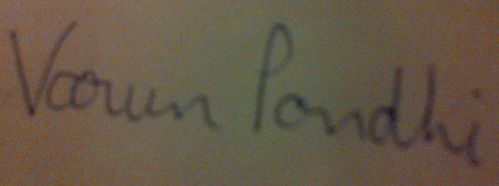
Varun Pandhi

